**Instructions:** You must show your work and put your final answers in the blanks. If you round a numerical answer, **you must give at least 3 significant digits**. **You have 20 minutes to finish the quiz and upload on Blackboard.**

**Q1.** (5 pts.) What is the Amplitude, Frequency, and Phase of the following analog signal, $v (t)$?

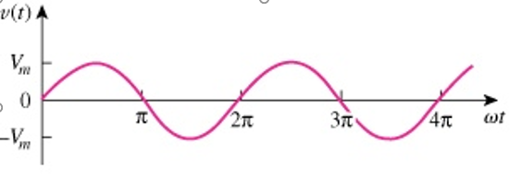

Answer: Amplitude = Vm, Frequency = 2pi, Phase = 0 at x = 0

**Q2.** (5 pts.) Discuss the Pros and Cons of a Digital system over an Analog system. Explain the role of Microcontroller, ADC, and DAC (shown in the diagram below) in an IoT system.

Micro-Controller

Binary

Number

Analog Signal

A/D Converter

Binary

Number

D/A Converter

Answer: Digital Systems can be viewed by electronical devices. Doing this though will limit the actual amount of data saved as it has to be stored in binary. Analog systems don’t have this limit, so the signals can be any amount of data.

Analog

Signal

A/D converter reads the analog signal and output’s it to binary. A micro-controller will read this and put it to a system. A D/A converter read binary from an electronic system and outputs to analog